

**Metro Shopping Mall**

Outstanding features for maintain a mall

**Supervisor**

Md. Anwar Hossen,

Lecturer (Senior Scale),

Department of Software Engineering, Daffodil International University

**Submitted By**

Md Mahamodul Islam (172 - 35 - 2152)

Akib Al-Amin (171 - 35 - 2120)

**Table of Content**

Contents

**Chapter 1: Introduction** 3

1.1 Case Study 3

1.2 Finding Gaps 3

**Chapter 2: System analysis** 3

2.1 Feasibility Study 3

2.1.2 Technical Feasibility 4

2.1.3 Economical Feasibility 5

2.2 Time estimation 5

2.3 Budget estimation 5

2.3.1 Development Cost 5

2.4 Project Requirements 6

2.5 Objectives 6

2.6 Motivation 7

2.7 Goals of this project 7

2.8 Stakeholders 7

**Chapter 3: Software Requirement Specification** 8

3.1 Functional Requirements 8

3.2 Non-Functional Requirements 12

3.2.1 Performance 12

3.2.2 Safety Requirements 12

3.2.3 Reliability & Availability 12

3.2.4 Fault Tolerance 12

3.2.5 Maintenance 13

3.3 Use Case Diagram & Description 14

3.3.1 Use Case Description: Shop Renter 15

Shop Renter 15

Use Case Diagram: Shopping mall Owner 16

3.3.2 Use Case Description: Shopping mall Owner (admin) 16

Use Case Diagram : Shop Owner 18

3.3.3 Use Case Description: Shopping mall Owner (admin) 18

# Chapter 1: Introduction

## 1.1 Case Study

We are living in a modern world where everywhere in the city we can easily find a common thing that is shopping mall. Where customers get all their necessary thing in one mall but for the shop owner or shopkeeper and owner of the mall they all need communication for maintain the mall. First of all, in our Website all shopkeeper and shop owner must have to register in the system then they login to the system and get to know about their paid amount of money. User (shopkeeper and owner) can view their profile. As shopping mall 1st floor get much priority rather than top flor so 1st floor rent is higher rather than top floor. Owner (Admin) who login into system and collect all rent and pay all utility bills (ex: electricity bill, gas bill) through the payment method. Owner can monitoring the all users and for emergency existence or any emergency notice can post to the all users.

## 1.2 Finding Gaps

As every user must monitor the website regular as there is available emergency notice. User should pay all their payment before a certain time. User should user their information and pay their payment so sharply because all their information will add into database.

# Chapter 2: System analysis

## 2.1 Feasibility Study

In this software project’s feasibility, we will be looking over all possible relevant factors like economical, technical and operational feasibility. Throughout this feasibility study we will be able to make a decision that our team is capable enough to develop this project or not. We will be analyzing those feasibility by analyzing the tools and technologies we are going to use and the requirement we are finding to have in our team members to contribute in different portions of this project are summarized below.

#### 2.1.1 Operational Feasibility

Everything is set up in such a way that the project will be finished within allotted time. From project manager to all associated stakeholders have given their time at any need. Any changes in project are manageable as project has designed in such a way to adapt every problem that arises.

Strategies in project development have assured the viability of the project. So far, analyzing our system we have come to a decision that this project is going to be operationally feasible.

1. Every shop renter and mall owner they can complete all their work through the system and save their time.

### 2.1.2 Technical Feasibility

In this project, we will use several modern technologies. So, we need to analyze based on some parameters like what technologies we are expecting to use, how many manpower we need to work with those technologies and if we don’t have manpower then how we are going to mitigate the risk. Let’s see what technologies we are expecting to use and how manpower our team has:

|  |  |  |
| --- | --- | --- |
| **Technologies** | **Manpower** | **Ways to mitigate** |
| Laravel Framework (Php)- backend | 2 | Not Required |
| Html, CSS, JavaScript, jQuery -(frontend) | 2 | Not Required |
| Using API, Libraries, MySQL Server | 1 | Need to train 2 members |
| Windows 10/Linux Ubunto | 2 | Not Required |

**Table 2.1.2:** Technological Feasibility​

### 2.1.3 Economical Feasibility

Economical feasibility deals with how much cost we need to develop this project additionally with how much production cost we need. We will analyze this part more on cost-analysis section

of this chapter.

## 2.2 Time estimation

We will estimate the whole project time required by using PERT time analysis methods. In this method, to​ = minimum time required for that activity, tp​ = maximum time required for that

activity, tm​ ​ = neither optimistic nor pessimistic time required & te​ ​ = PERT’s average time.

|  |  |  |  |  |  |  |
| --- | --- | --- | --- | --- | --- | --- |
| **Activity** | **Preceding**  **Activity** | **Number of days** | | | t​e = | *to*+4*tm*+*tp*    6 |
| to​ | tm​ | tp​ |
| Requirement Collection (A) | None | 2 | 3 | 6 |  | 3.33 |
| Feasibility Study (B) | A | 2 | 4 | 8 |  | 4.33 |
| Drawing Diagrams (C) | A, B | 3 | 6 | 9 |  | 6 |
| UI/UX design (D) | A, C | 5 | 8 | 12 |  | 8.17 |
| MVC Architecture Design (E) | A, C, D | 7 | 10 | 14 |  | 10.17 |
| Programming (F) | A, E | 10 | 15 | 25 |  | 15.83 |
| Testing (G) | F | 3 | 5 | 8 |  | 5.17 |

## 2.3 Budget estimation

In this section, we will be continuing our economical feasibility. We are expecting to use many use many tools and technologies. For this purpose, we might require pre and post fund for this project. In this section, we will be analyzing budget in two different scenarios. Those are:

### 2.3.1 Development Cost

|  |  |  |  |
| --- | --- | --- | --- |
| **Task/Technology** | **Low Estimation** | **High Estimation** | **Actual Estimation** |
| A new computer | BDT 45000 | BDT 80000 | BDT 65000 |
| Front-End Design | BDT 35000/Month | BDT 65000/Month | BDT 45000/Month |
| BackEnd Coding | BDT 85000/Month | BDT 150000/Mo | BDT 100000/Month |
| Testing | BDT 25000/Month | BDT 65000/Month | BDT 50000/Month |

## 2.4 Project Requirements

In this project all user (shop renter and shop owner) must create their account and admin should monitor them if user cannot create the account then project cannot be useful for this shopping mal. So all user must have to register into the system.

## 2.5 Objectives

The objective is the outcome of this project so the main goal is maintain the shopping mall where user will pay their all bills to the admin & admin will fix and calculate the rent for every shop which are categorized by according to level.

## 2.6 Motivation

As shopping mall is need for every person so we take the motivation from the general people.

|  |  |  |
| --- | --- | --- |
| **Key concepts** | **Obstacles to overcome** | **Intrinsic Motivation** |
| * Optimistic Energy * Autonomy * Feedback * Reward &   Recognition | * Less management   support   * Personal conflicts * Schedule conflicts * Time overrun * Increment of project scope | * Involve team early on * Understand team   members   * Matching assignments   and skills carefully   * Responsible team   leader   * Private motivation |

## 2.7 Goals of this project

The goal for this project as shopping mall owner can run his shopping mall without any interfere. He can complete all of his shopping mall work within a short time from anywhere he can live or stay. We want to apply this website for our countries large shopping mall later on.

## 2.8 Stakeholders

Developer, Shop Owner, Shop Renter, Shopping mall Owner.

# Chapter 3: Software Requirement Specification

## 3.1 Functional Requirements

|  |  |
| --- | --- |
| **FR-01** | Register |
| **Descriptions** | Shop renter must use their personal information & Shop owner also register into the system providing their personal information. |
| **Stakeholders** | Shop Owner, Shop renter |

|  |  |
| --- | --- |
| **FR-02** | Login |
| **Descriptions** | They must use their authentic credentials to enter the system as they are shop Owner or shop renter. |
| **Stakeholders** | Shop Owner, Shop renter, Shopping mall Owner |

|  |  |
| --- | --- |
| **FR-03** | Floor categorized |
| **Descriptions** | After successfully signing in, they can select their floor level .As level the total bill will show. |
| **Stakeholders** | Shop Owner, Shop renter |

|  |  |
| --- | --- |
| **FR-04** | User Profile |
| **Descriptions** | Where shop owner and shop renter see their profile and modify their any kind of information. |
| **Stakeholders** | Shop Owner, Shop renter |

|  |  |
| --- | --- |
| **FR-05** | Shop Rent |
| **Descriptions** | Where shopping mall set their rent for each floor shop as categorized wise shop renter see this and have to pay the amount |
| **Stakeholders** | Shop renter, Shopping mall Owner |

|  |  |
| --- | --- |
| **FR-06** | Utility bill |
| **Descriptions** | Without shop rent any other bill that shop renter have to pay that bill will generate by the shopping mall owner. |
| **Stakeholders** | Shop renter, Shop Owner, Shopping mall Owner |

|  |  |
| --- | --- |
| **FR-07** | Total payable |
| **Descriptions** | Total payable bill that will generate by the admin and user they see that have to pay the bill |
| **Stakeholders** | Shop renter, Shop Owner, Shopping mall Owner |

|  |  |
| --- | --- |
| **FR-08** | Total paid |
| **Descriptions** | If they not paid all the amount that they should have been paid then there will be paid amount. |
| **Stakeholders** | Shop renter, Shop Owner, Shopping mall Owner |

|  |  |
| --- | --- |
| **FR-09** | Total due |
| **Descriptions** | If they not paid all the amount that they should have been paid then there will be unpaid amount which will show to the user profile |
| **Stakeholders** | Shop renter, Shop Owner, Shopping mall Owner |

|  |  |
| --- | --- |
| **FR-10** | Payment |
| **Descriptions** | By using API, user can pay their amount of money to the bank or they can pay the amount cash in hand to Owner. |
| **Stakeholders** | Shop renter, Shop Owner |

|  |  |
| --- | --- |
| **FR-11** | Parking |
| **Descriptions** | Admin will monitor the parking area using cctv camera. |
| **Stakeholders** | Shopping mall Owner |

|  |  |
| --- | --- |
| **FR-12** | Floor Details Information |
| **Descriptions** | Where admin add the details information using form filed about each floor |
| **Stakeholders** | Shopping mall Owner |

|  |  |
| --- | --- |
| **FR-13** | Emergency notice |
| **Descriptions** | When in the shopping happen bad things or there is any emergency notice from the mall owner .mall owner can post it by using user session id the notice will show to the every user homepage. |
| **Stakeholders** | Shopping mall Owner |

|  |  |
| --- | --- |
| **FR-14** | Buy shop |
| **Descriptions** | When a shop renter want to buy a shop he can buy the shop by paying a certain amount of money. |
| **Stakeholders** | Shop Renter |

|  |  |
| --- | --- |
| **FR-15** | EMI facilities |
| **Descriptions** | When shop renter want to buy a shop they deserve an offer from shopping mall owner EMI facilities where they can the amount following some installment |
| **Stakeholders** | Shop Renter |

## 3.2 Non-Functional Requirements

### 3.2.1 Performance

|  |  |
| --- | --- |
| NFR-01 | The Landing page will responses within a second |
| Description | Response to view information shall take no longer than 5 seconds to appear on the screen |
| Stakeholders | Shop renter, Shop Owner |

### 3.2.2 Safety Requirements

|  |  |
| --- | --- |
| NFR-02 | System use shall not cause any harm to human users. |
| Description | System will designing as per requirement so that it does not harm any human user |
| Stakeholders | Shop renter, Shop Owner |

### 3.2.3 Reliability & Availability

|  |  |
| --- | --- |
| NFR-03 | The system must be available 24x7 |
| Description | The system must be available 24 hours a day. And it must be updated regularly |
| Stakeholders | N/A |

### 3.2.4 Fault Tolerance

|  |  |
| --- | --- |
| NFR-04 | Always updated the system |
| Description | If any problem occurs, then admin will show zero tolerance and fix it as soon as possible. |
| Stakeholders | Shopping mall owner |

### 3.2.5 Maintenance

|  |  |
| --- | --- |
| NFR-05 | The system helps to update any information in any time |
| Description | The admin change or update any information in any situation |
| Stakeholders | Shopping mall owner |

## 3.3 Use Case Diagram & Description

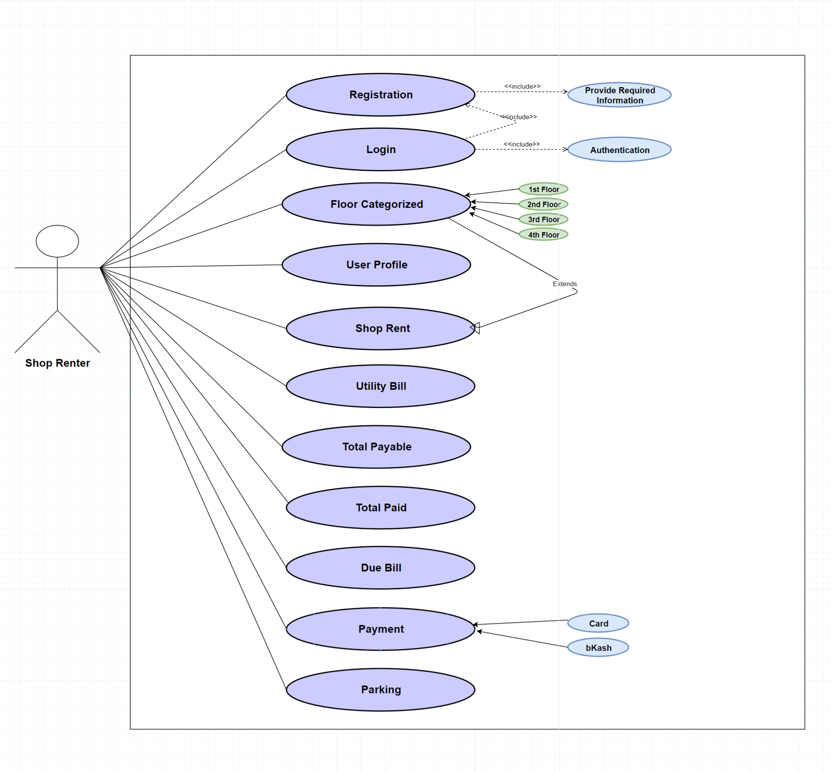

### 3.3.1 Use Case Description: Shop Renter

|  |  |  |  |  |
| --- | --- | --- | --- | --- |
| **Use Case** | Shop Renter | | | |
| **Goal** | Shop renter login the system and view all his information and also the all payment information. They can pay their bill using EMI service or cash in hand. | | | |
| **Preconditions** |  | | | |
| **Success End**  **Condition** | Shop renter complete their all requirements pay the bill and shopping mall owner check and approve the bill as paid. | | | |
| **Failed End Condition** | Shop renter cannot delay for paying the bill. They cannot modify any bill information if there is any wrong information. They should contact direct to shopping mall owner. | | | |
| **Primary Actors:**    **Secondary Actors:** | Shop renter & shopping mall owner | | | |
| **Trigger** | All these features starts working when shop renter are actually creating their profile and login into the system. | | | |
| **Description / Main**  **Success Scenario** | **Step** | **Action** | | |
| 1 | Shop renter creates their profile | | |
| 1.1 1.2 1.3 | By selecting his/her own subject floor as categorized wise  Then admin will provide the all information about bill  Shop renter can see the total bill | | |
| 2 | Then shop renter submit the form after paying all their bill. | | |
| 3 | Finally Admin will check approve the bill is approved and show the message to the shop renter | | |
| **Alternative Flows** | **Step** | **Branching Action** | | |
| 1. | Shop renter can pay their bill in hand in cash. | | |
| 2 | After admin approval. They will message as their bill has been paid. | | |
| **Quality**  **Requirements** | **Step** | **Requirement** | | |
| 3 |  | Enhanced user interface with lazy loading while server is |  |
| responding late. |

### Use Case Diagram: Shopping mall Owner

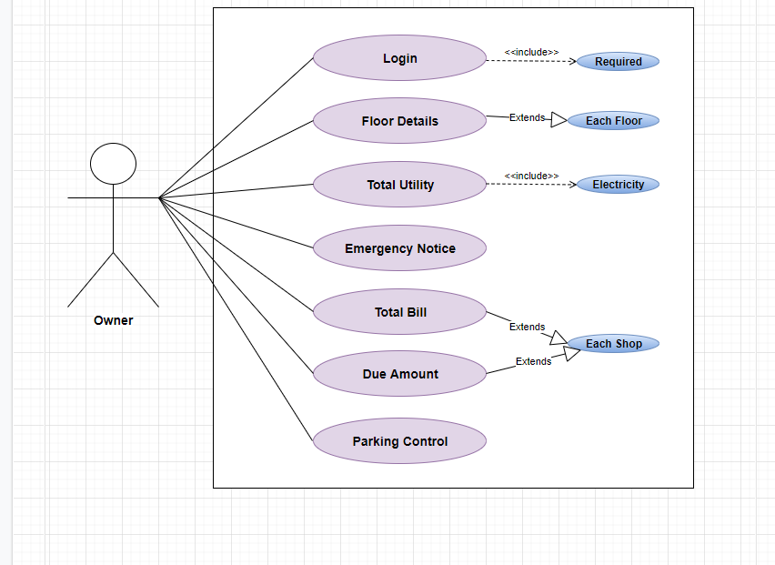

### 3.3.2 Use Case Description: Shopping mall Owner (admin)

|  |  |  |
| --- | --- | --- |
| **Use Case** | Shopping mall Owner | |
| **Goal** | When shop renter and shop owner complete their payment .admin will see the information and approved as done. Admin also monitor the all system and do the floor categorized. Admin will post emergency notice while this is needed. | |
| **Preconditions** |  | |
| **Success End**  **Condition** | Monitor the system &check user input and approved them and notice them whenever needed. | |
| **Failed End Condition** | Cannot modify any user information. | |
| **Primary Actors:**    **Secondary Actors:** | Shopping mall Owner  Shop renter, Shop owner | |
| **Trigger** | All these features starts working from the time when Shop renter, Shop owner are enrolling themselves and engaging themselves into the system and complete their payment. | |
| **Description / Main**  **Success Scenario** | **Step** | **Action** |
| 1 | Admin login into the system and show there is any user who need any approval. |
| 2 | Check dataset and take decision on dataset. |
| 3 | Approve the user bill. |
| 4 | Sometimes emergency notice is needed and admin will post this. |
|  |  |
| **Alternative Flows** | **Step** | **Branching Action** |
| 2 | Sometimes they got the bill in hand in cash.so they approve the payment complete after receiving the bill. |
| 3 | Sending the confirmation using Email API. |
| **Quality**  **Requirements** | **Step** | **Requirement** |
| 4 | A particular case of availability is concurrent access(both to read or to update data) by more than one user. |

### Use Case Diagram : Shop Owner

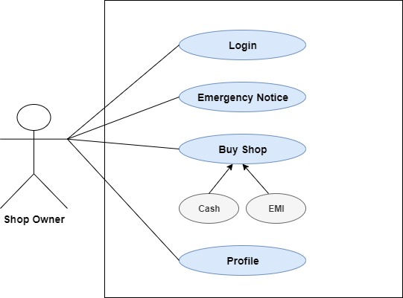

### 3.3.3 Use Case Description: Shopping mall Owner (admin)

|  |  |  |
| --- | --- | --- |
| **Use Case** | Shop owner | |
| **Goal** | When shop renter are want to buy a shop they can buy it using the system process .where they want to apply the system and admin will notify the user if yes then user can buy those shop and using EMI installment they can pay the total price of the shop. | |
| **Preconditions** |  | |
| **Success End**  **Condition** | Shop renter going to be a shop owner. They get a facilities EMI so using this service they can pay the shop price. | |
| **Failed End Condition** | Shop renter cannot delay for paying the bill. They cannot modify any bill information if there is any wrong information. They should contact direct to shopping mall owner. | |
| **Primary Actors:**    **Secondary Actors:** | Shopping mall Owner  Shop renter, Shop owner | |
| **Trigger** | All these features starts working from the time when Shop renter, Shop owner are enrolling themselves and engaging themselves into the system and complete their payment. | |
| **Description / Main**  **Success Scenario** | **Step** | **Action** |
| 1 | Shop renter creates their profile |
| 2 | By selecting his/her own subject floor as categorized wise  Then admin will provide the all information about bill  Shop renter can see the total bill |
| 3 | Then shop renter submit the form after paying all their bill. |
| 4 | Finally Admin will check approve the bill is approved and show the message to the shop renter |
|  |  |
| **Alternative Flows** | **Step** | **Branching Action** |
| 2 | Shop renter can pay their bill in hand in cash. |
| 3 | After admin approval. They will message as their bill has been paid. |
| **Quality**  **Requirements** | **Step** | **Requirement** |
| 4 | Enhanced user interface with lazy loading while server is responding late |